Linkific AI Internship
Name: Ankita Patil
Internship: AI/ML Intern

Day 1

Objectives
- Understand Artificial Intelligence (AI)
- Understand Machine Learning (ML)
- Understand Deep Learning (DL)
- Learn the difference between Supervised and Unsupervised Learning
- Observe AI-powered applications used in daily life
- Set up the development environment
- Create a GitHub repository for internship tasks
1. Introduction to Artificial Intelligence (AI)
Artificial Intelligence (AI) is a branch of computer science that enables machines to perform tasks that normally require human intelligence. These tasks include learning, reasoning, problem-solving, decision-making, understanding language, and recognizing images or speech.

Examples of AI
- ChatGPT – Generates human-like conversations and answers questions.
- Google Assistant – Understands voice commands and performs tasks.

2. Introduction to Machine Learning (ML)
Machine Learning (ML) is a subset of Artificial Intelligence that allows computers to learn from data without being explicitly programmed. Instead of following fixed rules, ML algorithms identify patterns in data and improve their predictions over time.
Machine Learning is widely used in recommendation systems, fraud detection, email filtering, and predictive analytics.

Examples of Machine Learning
- Netflix movie recommendations
- Gmail spam detection

3. Introduction to Deep Learning (DL)
Deep Learning is a specialized subset of Machine Learning that uses Artificial Neural Networks with multiple hidden layers to learn complex patterns from large amounts of data.
Deep Learning is particularly effective in computer vision, speech recognition, natural language processing, and autonomous systems.

Examples of Deep Learning
- Face Unlock on smartphones
- Voice assistants like Siri and Alexa

4. Difference Between AI, ML, and Deep Learning
Artificial Intelligence | Machine Learning | Deep Learning
Broad field of creating intelligent systems | Subset of AI | Subset of Machine Learning
Can use rules and learning | Learns from data | Learns using deep neural networks
Less dependent on large datasets | Requires training data | Requires large datasets and high computing power
Examples: ChatGPT, Robots | Spam Detection | Face Recognition

5. Difference Between Supervised and Unsupervised Learning
Supervised Learning | Unsupervised Learning
Uses labeled data | Uses unlabeled data
Output is known | Output is unknown
Used for prediction and classification | Used to discover hidden patterns
Example: Email Spam Detection | Example: Customer Segmentation

6. AI Around You – Observation Report
Application | Problem It Solves | How AI Improves User Experience | AI Category
Google Maps | Navigation and route planning | Predicts traffic, suggests fastest routes, and estimates arrival time | Machine Learning
YouTube | Finding relevant videos | Recommends personalized videos based on watch history | Machine Learning
ChatGPT | Answering questions and content generation | Understands user queries and generates human-like responses | Generative AI
Spotify | Music recommendation | Suggests songs and playlists based on listening behavior | Machine Learning
Instagram | Personalized content feed | Recommends posts and reels using image recognition and user behavior analysis | Deep Learning

7. Development Environment Setup
The following software was successfully installed:
- Python
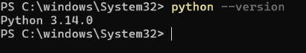
- Visual Studio Code (VS Code)
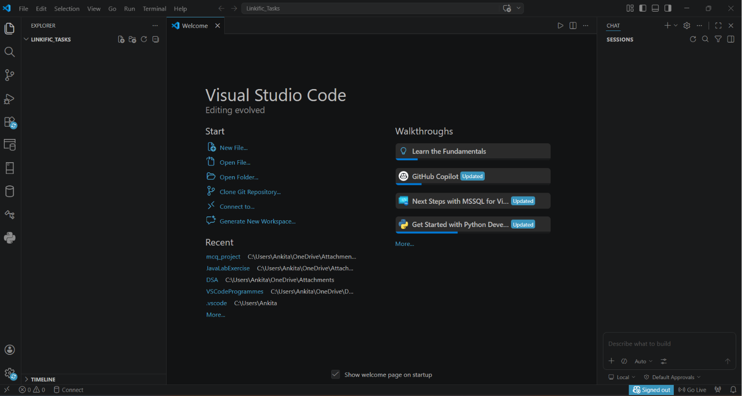
- Git
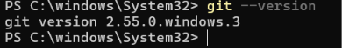
- GitHub Account Created
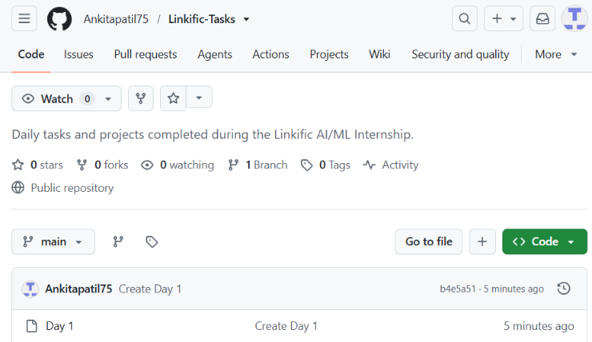

9. Learning Outcome
Today, I learned the basic concepts of Artificial Intelligence, Machine Learning, and Deep Learning. I understood the differences between supervised and unsupervised learning and explored how AI is integrated into applications that I use daily. I also completed the development environment setup by installing Python, VS Code, Git, and creating a GitHub repository for managing internship tasks.

